在里面用户可以下拉树面板（tree panel），并选择一个特定的城市。

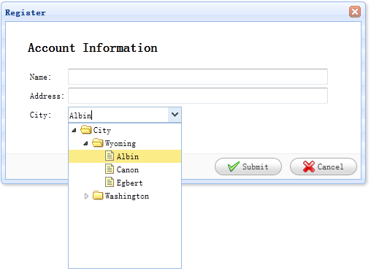

#### 创建表单（Form）

    <div id="dlg" class="easyui-dialog" style="width:500px;height:250px;padding:10px 30px;"

            title="Register" buttons="#dlg-buttons">

        <h2>Account Information</h2>

        <form id="ff" method="post">

            <table>

                <tr>

                    <td>Name:</td>

                    <td><input type="text" name="name" style="width:350px;"/></td>

                </tr>

                <tr>

                    <td>Address:</td>

                    <td><input type="text" name="address" style="width:350px;"/></td>

                </tr>

                <tr>

                    <td>City:</td>

                    <td><select class="easyui-combotree" url="data/city_data.json" name="city" style="width:156px;"/></td>

                </tr>

            </table>

        </form>

    </div>

    <div id="dlg-buttons">

        <a href="#" class="easyui-linkbutton" iconCls="icon-ok" onclick="savereg()">Submit</a>

        <a href="#" class="easyui-linkbutton" iconCls="icon-cancel" onclick="javascript:$('#dlg').dialog('close')">Cancel</a>

    </div>